Prop in react

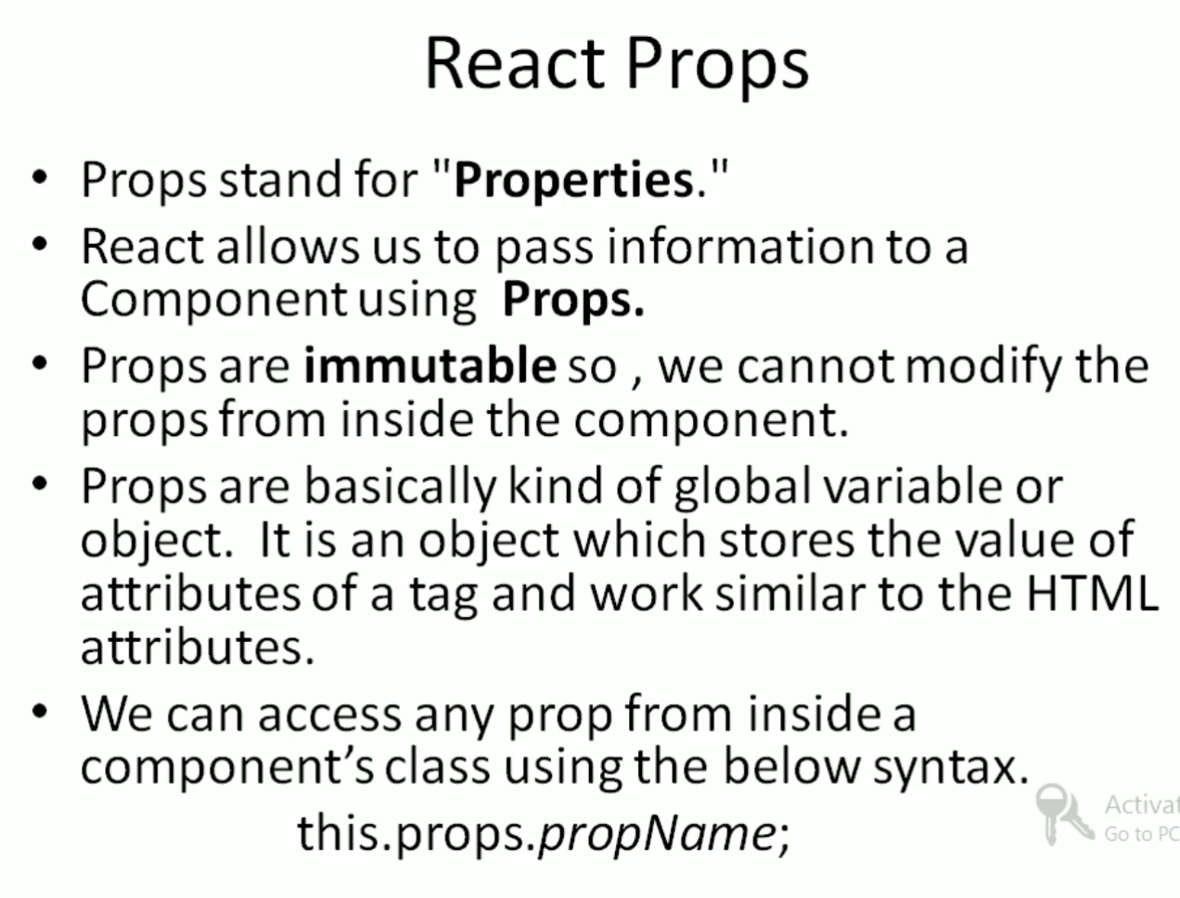

Just to Keep the separation of Concepts

Create a new File with the name of SingleProps.jsx

import React, { Component } from 'react';

class SingleProps extends Component {

    state = {  }

    render() {

        return (

            <div>

                <h1> Hello, {this.props.name}</h1>

            </div>

        );

    }

}

export default SingleProps;

app.js

 <SingleProps />

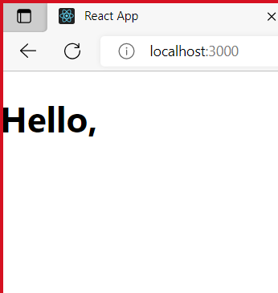

 <SingleProps name="Peter"/>

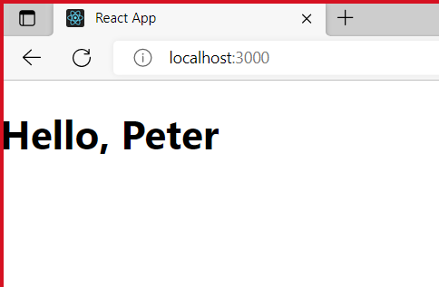

Example for MultipleProps

import React, { Component } from 'react';

class SingleProps extends Component {

    state = {  }

    render() {

        return (

            <div>

                <h1> Hello, {this.props.name} Welcome to Hexaware</h1>

                <h2>  Learn {this.props.topics} {this.props.concept}

                in {this.props.language}</h2>

            </div>

        );

    }

}

export default SingleProps;

app.Js

  <SingleProps name="Geetha" topics="React Native" concept="PROPS"

        language="German" />



Create newFile ParentToChild.jsx

import React, { Component } from 'react';

    class PropsParent extends Component {

        state = {  }

        render() {

            return (

                <div>

                    <h1> Learn {this.props.var.topic} in {this.props.var.language}</h1>

                </div>

            );

        }

    }

    class PropsChild extends Component {

        state = {  }

        render() {

            const detail={topic:"Vue Js", language:"Tamil"}

            return (

                <div>

                    <PropsParent var={detail} />

                </div>

            );

        }

    }

    export default PropsChild;

App.jsx

 <PropsChild />

Output



Create a new Folder (PropsDemo) in SRC Folder

Create a new File (SingleProp.jsx)

import React from 'react';

import ReactDOM from 'react-dom';

export default class Learnreactprops extends React.Component

{

  render()

  {

    return <div>

      <h1>Learn {this.props.topic} in {this.props.language}</h1>

    </div>

  }

}

App.js

import logo from './logo.svg';

import './App.css';

import { Component } from 'react';

import SingleProps from '../src/PropsDemos/SingleProps';

class App extends Component

{

  render(){

    return (<div>

      <SingleProps topic="React Js" language="Tamil" />

      </div>

      )

  }

}

export default App;



How to pass props from child class to parent class

Create a new file with the name ParentToChild.jsx

import React from 'react';

import ReactDOM from 'react-dom';

 class Learnreactpropsparent extends React.Component

{

  render()

  {

    return <div>

      <h1>Learn React JS in {this.props.var}</h1>

    </div>

  }

}

export default class Learnreactpropschild extends React.Component

{

  render()

  {

    const v = "English";

    return <Learnreactpropsparent var={v} />

  }

}

App.js

import logo from './logo.svg';

import './App.css';

import { Component } from 'react';

 import Learnreactpropschild from '../src/PropsDemos/ParentToChild';

class App extends Component

{

  render(){

    return (<div>

      <Learnreactpropschild />

      </div>

      )

  }

}

export default App;

output



How to pass object to property

parentToChild.jsx

import React from 'react';

import ReactDOM from 'react-dom';

 class Learnreactpropsparent extends React.Component

{

  render()

  {

    return <div>

      <h1>Learn {this.props.var.topic} {this.props.var.concept} in {this.props.var.language}</h1>

    </div>

  }

}

export default class Learnreactpropschild extends React.Component

{

  render()

  {

    // const v = "English";

    const v={topic:"React Js",language:"Tamil",concept:'Props'}

    return <Learnreactpropsparent var={v} />

  }

}



How to pass defaultProperties

ParentToChild.jsx

import React from 'react';

import ReactDOM from 'react-dom';

 export default class Learnreactpropsparent extends React.Component

{

  render()

  {

    return <div>

      <h1>Learn {this.props.topic} {this.props.concept} in {this.props.language}</h1>

    </div>

  }

}

//export default

 class Learnreactpropschild extends React.Component

{

  render()

  {

    return <Learnreactpropsparent />

  }

}

const v1 ={concept:"React Native", language:"english", concept: "Props vs State"};

Learnreactpropsparent.defaultProps =v1;

App.Jsx

import logo from './logo.svg';

import './App.css';

import { Component } from 'react';

 import Learnreactpropsparent from '../src/PropsDemos/ParentToChild';

class App extends Component

{

  render(){

    const v={topic:"React Js",language:"Tamil",concept:'Props'};

    return (<div>

      <Learnreactpropsparent />

      <Learnreactpropsparent topic="React Js" language="Tamil" concept='Props'/>

      </div>

      )

  }

}

export default App;

output

